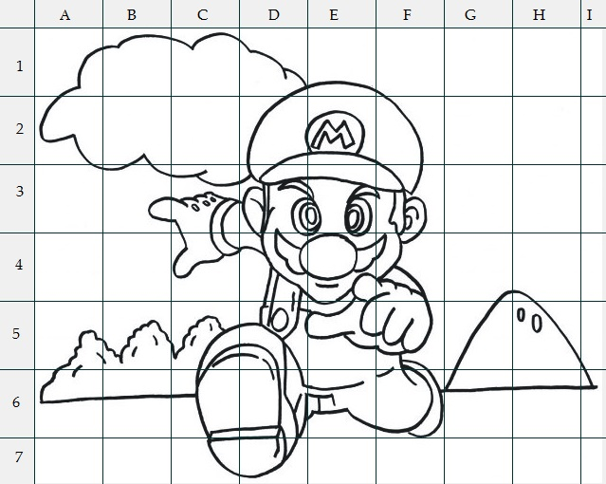

|  |  |  |  |  |  |  |  |  |  |
| --- | --- | --- | --- | --- | --- | --- | --- | --- | --- |
|  | A | B | C | D | E | F | G | H | L |
| 1 |  |  |  |  |  |  |  |  |  |
| 2 |  |  |  |  |  |  |  |  |  |
| 3 |  |  |  |  |  |  |  |  |  |
| 4 |  |  |  |  |  |  |  |  |  |
| 5 |  |  |  |  |  |  |  |  |  |
| 6 |  |  |  |  |  |  |  |  |  |
| 7 |  |  |  |  |  |  |  |  |  |

Nome ………………………………………. Cognome……………………………………………………………..

Classe …………………. Data………………………………………….

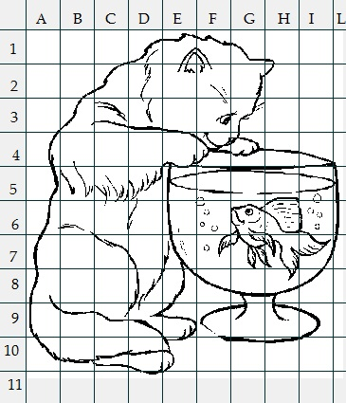

Nome ………………………………… Cognome…………………………..

Classe …………………. Data…………………….

|  |  |  |  |  |  |  |  |  |  |  |
| --- | --- | --- | --- | --- | --- | --- | --- | --- | --- | --- |
|  | A | B | C | D | E | F | G | H | I | L |
| 1 |  |  |  |  |  |  |  |  |  |  |
| 2 |  |  |  |  |  |  |  |  |  |  |
| 3 |  |  |  |  |  |  |  |  |  |  |
| 4 |  |  |  |  |  |  |  |  |  |  |
| 5 |  |  |  |  |  |  |  |  |  |  |
| 6 |  |  |  |  |  |  |  |  |  |  |
| 7 |  |  |  |  |  |  |  |  |  |  |
| 8 |  |  |  |  |  |  |  |  |  |  |
| 9 |  |  |  |  |  |  |  |  |  |  |
| 10 |  |  |  |  |  |  |  |  |  |  |
| 11 |  |  |  |  |  |  |  |  |  |  |

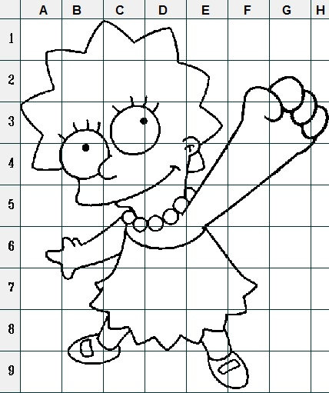

|  |  |  |  |  |  |  |  |  |
| --- | --- | --- | --- | --- | --- | --- | --- | --- |
|  | A | B | C | D | E | F | G | H |
| 1 |  |  |  |  |  |  |  |  |
| 2 |  |  |  |  |  |  |  |  |
| 3 |  |  |  |  |  |  |  |  |
| 4 |  |  |  |  |  |  |  |  |
| 5 |  |  |  |  |  |  |  |  |
| 6 |  |  |  |  |  |  |  |  |
| 7 |  |  |  |  |  |  |  |  |
| 8 |  |  |  |  |  |  |  |  |
| 9 |  |  |  |  |  |  |  |  |

Nome ………………………………………. Cognome……………………………………………………………..

Classe …………………. Data………………………………………….

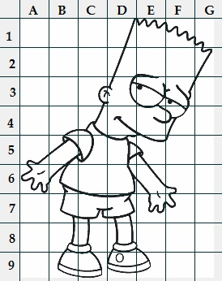

|  |  |  |  |  |  |  |  |
| --- | --- | --- | --- | --- | --- | --- | --- |
|  | A | B | C | D | E | F | G |
| 1 |  |  |  |  |  |  |  |
| 2 |  |  |  |  |  |  |  |
| 3 |  |  |  |  |  |  |  |
| 4 |  |  |  |  |  |  |  |
| 5 |  |  |  |  |  |  |  |
| 6 |  |  |  |  |  |  |  |
| 7 |  |  |  |  |  |  |  |
| 8 |  |  |  |  |  |  |  |
| 9 |  |  |  |  |  |  |  |

Nome ………………………………………. Cognome……………………………………………………………..

Classe …………………. Data………………………………………….

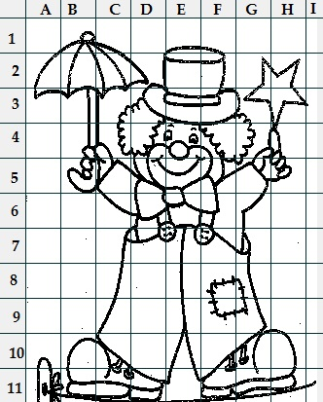

Nome ………………………………… Cognome…………………………..

Classe …………………. Data…………………….

|  |  |  |  |  |  |  |  |  |  |
| --- | --- | --- | --- | --- | --- | --- | --- | --- | --- |
|  | A | B | C | D | E | F | G | H | I |
| 1 |  |  |  |  |  |  |  |  |  |
| 2 |  |  |  |  |  |  |  |  |  |
| 3 |  |  |  |  |  |  |  |  |  |
| 4 |  |  |  |  |  |  |  |  |  |
| 5 |  |  |  |  |  |  |  |  |  |
| 6 |  |  |  |  |  |  |  |  |  |
| 7 |  |  |  |  |  |  |  |  |  |
| 8 |  |  |  |  |  |  |  |  |  |
| 9 |  |  |  |  |  |  |  |  |  |
| 10 |  |  |  |  |  |  |  |  |  |
| 11 |  |  |  |  |  |  |  |  |  |

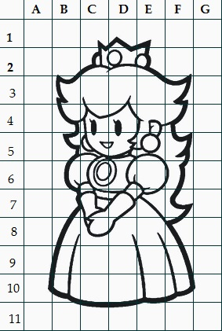

Nome ………………………………… Cognome…………………………..

Classe …………………. Data…………………….

|  |  |  |  |  |  |  |  |
| --- | --- | --- | --- | --- | --- | --- | --- |
|  | A | B | C | D | E | F | G |
| 1 |  |  |  |  |  |  |  |
| 2 |  |  |  |  |  |  |  |
| 3 |  |  |  |  |  |  |  |
| 4 |  |  |  |  |  |  |  |
| 5 |  |  |  |  |  |  |  |
| 6 |  |  |  |  |  |  |  |
| 7 |  |  |  |  |  |  |  |
| 8 |  |  |  |  |  |  |  |
| 9 |  |  |  |  |  |  |  |
| 10 |  |  |  |  |  |  |  |
| 11 |  |  |  |  |  |  |  |